

Mini Project Report - 02

Master of Computer Application – General
Semester – I

Sub: Frontend Frameworks and Technology

Topic: Resume
By
Name: Ashraj Singh Rana
Reg no.: PROV/ASAC/MCA/7/26/058

Faculty Name: VEERA RAGHAV K

Faculty Signature: _______________

Department of Computer Application
Alliance University
Chandapura - Anekal Main Road, Anekal
Bengaluru - 562 106
August 2025

INTRODUCTION
A resume website is a responsive web-based project developed using HTML and CSS to present a individual’s professional profile, educational background, technical skills, work experience, achievements and contact information in a clear and organized manner. The website follows a clean and professional layout withs sections such as profile, career objectives, education, skills, experience, project, certifications and contact details. HTML is used to structure and arrange the resume content, while CSS is used to design the visual appearances, including colours, typography, spacing, section, layouts, buttons, and responsive elements. CSS is used to design the visual appearance, including colours, typography, spacing, section, layouts, buttons, and responsive elements. CSS is used to design the visual appearance, including colour.

INDEX

Fig No. | Name of table | Page No.
1. | Introduction | 1
2. | Input Code | 2 – 7
3. | Output | 8
4. | Conclusion | 9

INPUT CODE
<!DOCTYPE html>
<html lang="en">

<head>
<meta charset="UTF-8">
<meta name="viewport" content="width=device-width, initial-scale=1.0">
<title>Ashraj Singh Rana - Resume</title>
<style>
* {
box-sizing: border-box;
}

body {
background-color: #eeeeee;
color: #222222;
font-family: Arial, sans-serif;
line-height: 1.5;
margin: 0;
}

.resume {
background-color: white;
margin: 30px auto;
max-width: 850px;
padding: 45px 55px;
}

header {
border-bottom: 2px solid #333333;
padding-bottom: 20px;
}

h1 {
font-size: 36px;
margin: 0 0 5px;
}

.job-title {
color: #555555;
font-size: 18px;
margin: 0 0 12px;
}

.contact {
font-size: 14px;
}

.contact a {
color: #333333;
}

section {
border-bottom: 1px solid #dddddd;
padding: 22px 0;
}

section:last-of-type {
border-bottom: 0;
}

h2 {
color: #d45d4f;
font-size: 20px;
margin: 0 0 12px;
text-transform: uppercase;
}

h3 {
font-size: 17px;
margin: 0 0 3px;
}

p {
margin: 5px 0;
}

ul {
margin: 8px 0 0;
padding-left: 20px;
}

li {
margin-bottom: 5px;
}

.education-line,
.project-line {
color: #555555;
font-size: 14px;
}

.skills span {
background-color: #eeeeee;
display: inline-block;
margin: 4px 4px 4px 0;
padding: 5px 10px;
}

@media (max-width: 600px) {
.resume {
margin: 0;
padding: 30px 22px;
}

h1 {
font-size: 30px;
}
}

@media print {
body {
background-color: white;
}

.resume {
margin: 0;
padding: 25px;
}
}
</style>
</head>

<body>
<main class="resume">
<header>
<h1>Ashraj Singh Rana</h1>
<p class="job-title">MCA Student | Full-Stack Developer</p>
<p class="contact">
Email: <a href="mailto:ashrajsingh9@gmail.com">ashrajsingh9@gmail.com</a> |
Phone: <a href="tel:+917418529630">+91 9827900755</a> |
India
</p>
</header>

<section>
<h2>Career Objective</h2>
<p>I am an MCA student who enjoys building simple and useful websites. I am looking for an opportunity to
improve my development skills and work on real-world projects.</p>
</section>

<section>
<h2>Education</h2>
<h3>Master of Computer Applications (MCA)</h3>
<p class="education-line">Alliance University | Expected graduation: 2026</p>
</section>

<section>
<h2>Technical Skills</h2>
<div class="skills">
<span>HTML</span>
<span>CSS</span>
<span>JavaScript</span>
<span>React</span>
<span>Node.js</span>
<span>Express</span>
<span>MongoDB</span>
<span>Git</span>
</div>
</section>

<section>
<h2>Projects</h2>
<h3>BALANCEO — Finance Management Web App</h3>
<p class="project-line">React · Node.js · Express · MongoDB · TypeScript · JWT · Recoil · Rende</p>
<ul>
<li>Migrated full codebase from JavaScript to TypeScript, fixed broken production build pipeline, and
deployed on
Render with UptimeRobot health checks</li>
<li> Implemented JWT authentication, bcrypt password hashing, protected routes, Recoil state management,
and
income/expense analytics dashboard</li>
</ul>

<h3 style="margin-top: 18px;">CATCHUP — Real-Time Chat Application </h3>
<p class="project-line">MongoDB · Express · React · Node.js · WebSocket</p>
<ul>
<li> Built real-time messaging using WebSocket connections with privacy-first architecture — users
communicate via
unique private IDs, no personal data exposed
</li>
</ul>
<h3 style="margin-top: 18px;">BOOKVAULT — Library Management System </h3>
<p class="project-line">Python · Django · Django ORM · SQLite · HTML · CSS</p>
<ul>
<li>Full-stack library system with role-based dashboards for librarians and students — book issuance,
returns, fine tracking,
and availability counts using Django ORM
</li>
</ul>
</section>

<section>
<h2>Certifications</h2>
<p>Full Stack Development Cohort (MERN)</p>
<p>NPTEL — Programming with Generative AI</p>
</section>

<section>
<h2>Strengths</h2>
<ul>
<li>Willingness to learn new technologies</li>
<li>Problem-solving and attention to detail</li>
<li>Teamwork and communication</li>
</ul>
</section>
</main>
</body>

</html>

OUTPUT
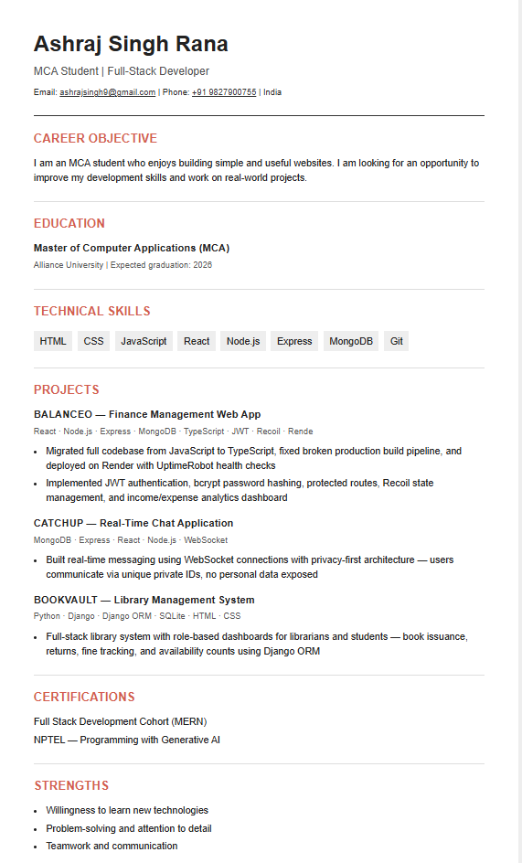
CONCLUSION
Resume website successfully demonstrates the use of HTML and CSS to create a structured, responsive and professional digital resume. The project presents personal information, career objective educational qualifications, technical skills, work experience, projects, certifications, and contact details in a clear and organized format. CSS styling, flexible layouts, color schemes, typography, section cards, hover effects, and responsive media quires improve the visual appearance and usability of the website. Through this project, essential front end development concepts such as webpage structure, styling, responsive, design, layout management and user-friendly navigation were practically implemented. Overall, the project provides an effective online platform for presenting an individual’s professional profile.

